PERSONAL DATABASE MANAGEMENT SYSTEM FOR STAFF RECORD KEEPING
(A CASE STUDY OF FEDERAL POLYTECHNIC NEKEDE OWERRI)
FEDERAL POLYTECHNIC NEKEDE OWERRI

BY

IKEGWURUKA PRECIOUS
12E/0397/CS
A PROJECT SUBMITTED TO THE DEPARTMENT OF COMPUTER SCIENCE, SCHOOL OF INDUSTRIAL AND APPLIED SCIENCE TECHNOLOGY.

IN PARTIAL FULFILLMENT OF THE REQUIREMENTS FOR THE AWARD OF HIGHER NATIONAL DIPLOMA (HND) IN COMPUTER SCIENCE FEDERAL POLYTECHNIC NEKEDE OWERRI.
DECEMBER, 2014.
CERTIFICATION
This is to certify that this project work on Personal Database Management System for Staff Record Keeping (A Case Study of Federal Polytechnic Nekede Owerri. (FPNO) Department of Federal Polytechnic Nekede with Reg. No. 12E/0397/CS of the Department of Computer Science, School of Industrial and Applied Science Federal Polytechnic Nekede, Owerri Imo State.

…………………………… ……………….
Mr. BABATUNDE OLOFIN DATE
(SUPERVISOR)

……………………………. ……………….
MRS.VICTORIA OYEDEPO DATE
(HEAD OF DEPARTMENT)

……………………………... ………………..
(EXTERNAL EXAMINER) DATE

DEDICATION
I dedicate this project to God Almighty, the beginning and the end of every case, the Afar and Omega, who gave me strength, love, protection throughout my year in this institution.
I indebted to my Late Dad, Mr. Augustine Ikegwuruka for his parental care for me to be a graduate, may your soul rest in peace Dad, also to my Lovely Mother Mrs. Victoria Ikegwuruka, for her prayer, love and caring and my lovely sisters, In-Laws and brothers for their support to make me succeed.
I won’t forget my beloved Sister who gave me courage and support throughout my schoolings, may the Almighty God guide her and protect her and family.

ACKNOWLEDGEMENTS
My acknowledgement goes to God Almighty, for his love, mercy throughout all the academic section. Also my parents, brothers, Sisters, Uncles, Aunty and In-Laws for encouragement and Support.
My acknowledgement goes to my lovely supervisor, Mr. Babatunde Olofin for his caring as a father to all students under his supervision, also to all lecturers in Computer Science both senior and junior, who help us to know some practical aspect?
My acknowledgement goes to Mrs. Victoria Ikegwuruka for her support and love she gave to me during my staying in her office.
My acknowledgement goes to my friends, colleagues both in school and in work place for their encouragement to work and succeed, thanks to you all Amen.
My acknowledgement goes to my In-laws Mr. and Mrs. Esther Ihedoro, my brothers and sisters which in any way support me may God in his infinite mercy bless you.
May God bless you all Amen.
IKEGWURUKA PRECIOUS

TABLE OF CONTENTS
Cover page i
Approval page ii
Dedication iii
Acknowledgments iv
Table of contents v-viii
Abstract ix
CHAPTER ONE
  - Introduction 1
  - Background of Study 2
  - Statement of the Problem 3
  - Objective of the Study 4
  - Significance of the Study 5
  - Scope of the Study 5
  - Limitation of the Study 6
  - Definition of Terms 7
CHAPTER TWO: REVIEW OF RELATED LITERATURES.
2.1 Introduction 10
  - Staff record keeping 14
  - Problems encountered 15
  - Prospects of computerized record keeping 15

CHAPTER THREE
3.1 Introduction 17
3.2 System Analysis 17
3.2.1 Detailed Definition of the Problem 18
3.2.2 Feasibility Study 19
3.3 Method of Data Collection 19
3.3.1 Interviewing 20
3.3.2 Questionnaire 20
3.3.3 Analysis of facts 21
3.3.4 Interviewer / Analysis 21
3.3.4 Observation methods 23
3.3.6 Review of Procedure Manuel or Exiting System/Procedure 24
3.3.7 Evaluation of Forms 25
3.8 Problem of Existing System or Draw Backs Identified In 30
3.8.1 Proposing of the new system 31
3.9 Data Preparation 32
3.10 Objective of The system Design 33
3.12 Program Structure 35
3.12.1 Modularity 35
3.12.2 Top-Down Program Design 36
3.12.3 System flowchart 38
3.13 File Maintenance Module 43
3.14 Main Menu Specification 43
3.14.1 Output Specification 44
3.14.5 File/Database Specification 56
3.15 Overview of the Proposed Systems Flowchart 56

CHAPTER FOUR
4.1 Introduction 57
4.2 Justification of the Programming Language 57
4.3 System Control 58
4.4 System Requirement 58
4.4.1 Software Requirement 58
4.4.2 Hardware Requirement 59
4.4.3 People 60
4.5 Implementation Details 60
4.5.1 Coding 60
4.5.2 System Testing 60
4.5.3 Training and Re-Training Of Staff 61
4.5.4 File Conversion 61
4.4.5 Change Over Procedure 62
4.5.6 Commission 63
4.5.7 User Manuals 64
4.5.8 Maintenance Details 64

CHAPTER FIVE
Summary, Recommendation and Conclusion
  - Summary 65
  - Recommendation 65
  - Conclusion 66
References 68
Appendix I - Sample Output
Appendix II - Source Code

ABSTRACT

This project was written in order that the problems encountered during staff records keeping (i.e. Personal Database Management System) and its management with the manual and mechanical method will be modernized and efficiently facilitating in the sense that staff records keeping and its database management system and management will no longer be a procession of tedious and boring issues, but rather would be a procession of reliable and comfortable issue. This aims also channeling towards improving method of Personal Database Management System in school of Federal Polytechnic Nekede. This goal can be realized through the following steps: 1) Analyzing the manual methods of keeping records of staff in school of Federal Polytechnic Nekede: 2) Defining the electronic data processing comparing it with manual data processing, bringing out the advantages of the former one: 3) Find out the best method or ways of keeping record of staff in the school of science, engineering and technology. A functional software was developed to implement the personal database management system i.e. keeping staff records of school of Federal Polytechnic Nekede, the institution using ASP.NET/C-Sharp, Microsoft SQL Server 2008 or 2012 due to its rich graphical user interface and event driven nature while the database was created using SQL Server. All these will be achieved using different tools and techniques.

CHAPTER ONE
INTRODUCTION
  - BACKGROUND OF THE STUDY
Record keeping is very important in human life, back during our forefathers’ time; stones were used in keeping their records. The ideal of record keeping is evidence in all aspect of human endeavors. Any organization keeps records, which may be of staff, student, goods the organization produces, record of daily activities records of annually transaction etc. In the hospital, if the record of a patient is not properly kept, the nature of the sickness and the kind of treatment the patient is undergoing cannot be easily addressed. In the field of education, the record of staffs and students needs to be kept properly. When the need of man started to increase in any organization, the record to be kept started to increase as well. The usual manual method of keeping record (e.g. using pen and paper) were gradually being replaced with mechanical methods continued until recently computers where developed as an electronic method of processing data. Computer is an electronic device that is capable of storing data, as input, processing it and finally producing information as output which is used in decision making for smooth running of any organization and institution. The reason of the invention of computer is to alleviate human complex nature of problems, at the end of this project work ("PERSONAL DATABASE MANAGEMENT SYSTEM i.e. for KEEPING RECORDS OF STAFF) in School of Federal Polytechnic Nekede" we will realize the type of record kept in Federal Polytechnic Nekede, better ways of keeping staff record will be suggested as well as the user of computers.
  - BACKGROUND OF THE STUDY
In Federal Polytechnic Nekede, the type of record keeping kept are student record keeping, staff record keeping, academic records keeping and books record keeping. This project work is going to base on staff record keeping. In the above school, staffs are categorized into Senior and junior staffs, the admission and welfare of workers see that the staffs in federal polytechnic are discipline and staff promotion are taking care of base on their record keepings. A computer then is a device that works under the control of stored programs, automatically accepting, storing and processing data to produce information i.e the result of that processing. The advantages offered by the computer system to individual firms, organizations and governmental establishment and institutions are enormous without questioning data are one of the most important resources of any organization, institution and government. Without data, an organization, institution would not be able to perform quite a number of its responsibilities and it would have adverse effect on the abilities of its decision making process. In this end, the complex problems on how best to keep records of the staffs have evolved. These problems can only be solved if computerization is implemented, in Federal Polytechnic Nekede, Owerri. The method of processing data is manual and mechanical method. This study centers its aim at reducing the problem encountered in keeping staff records and this has led to the suggestion that staff records keeping in Federal Polytechnic Nekede should be computerized.
  - STATEMENT OF THE PROBLEM
In Federal Polytechnic Nekede, since student and staff records keeping are kept manually, there have been problems which are being encountered. Computer has been developed to arrest most structured problems faced by man, as they can be applied in all field of human endeavors. It can be used to store records due to it’s expanding memory unit; it results to problem, which will be created by old system since records of staffs are kept manually, these have been a problem that is been encountered. The setback attribute to the traditional file system or manual method of data processing includes the following: 1) Delay in the processing of input (data) or information: 2) Lost of staff record in transit: 3) Human errors in records handling: 4) Delay information retrieval: 5) Time wastage in creation of staff records keeping: 6) Wastage of paper materials due to large volume of data files: 7) Inability to remove outdated records: 8) Updating of files of reflect the current states, papers wastage due to the value of data stored manually. This project is aimed at getting this problem solved through the design of data base system for keeping record of staff and information. And it can only be solved when computerization is implemented. When we automatically change from manual to electronic method of data processing a lot of problems volutes. Such problems of amendments can be enumerated as:
- What computes are all about?
- What extent will it fit the management of staff records keeping in Federal Polytechnic Nekede?
- What changes will it bring about?
- What are the implementations of the new system? It is among mission of this project work to provide answers to the question above.
  - OBJECTIVES OF THE STUDY
This project work is numerous goals to achieve its aim channeling towards improved methods of keeping staff record and other associated information, in Federal Polytechnic Nekede. This work will help to achieve a computerized exercise in Federal Polytechnic Nekede, at the end of this project work, these goal can be realized through the following steps.
- Analyzing the manual method of record keeping of staff.
- Defining electronic data processing, comparing it with manual data processing bringing out the advantages over manual methods.
- Find out the best method of keeping staff records and associated information in Federal Polytechnic Nekede, Owerri.
- Benefit of computerization which includes: accuracy of information, security of staff files or records keeping, improve ways of processing, efficiency and speedy rate of operation.
The above objectives will be achieved using different tools and techniques.
  - SIGNIFICANT OF THE STUDY
This is a convincing hope that this project will solve most of the problems encountered by this institution in its staff record keeping in school of Science, Engineering and Technology in managing its staff records keeping and its associated information. This is only true if the suggestion may be strictly be adhered to and implemented. Among the numerous importance are: a) Accuracy and speedy processing of information: b) Quick access to individual records keeping: c) Improve file organization and management.
This project work will also necessitate the modification and refinement of the already existing techniques and it will also serve as a guide to others who may be researching on this same topics. And also as reference work in Federal Polytechnic Nekede Library.
  - SCOPE OF THE STUDY
The project work has much to do with files generation, file creation and file organization of staff record keeping. In the course of the study, file security measures will be suggested to enhance keeping of staff keeping in school of Science, Engineering and Technology in Federal Polytechnic Nekede Owerri Imo State.
  - LIMITATION AND DELIMITATION OF THE STUDY
Due to the fact that school of Federal Polytechnic Nekede Owerri as the case study, this study is limited in scope to school of Federal Polytechnic Nekede Owerri. Due to the attitude on the concerned staff in the good supply of information, I was unable to get facts and data right as it were. So it affected the system design of the program. Also the inability of the management of the institution to provide a general network system for the institution contravened this project work to a single user platform and also due to the non-availability of other powerful database management system like ORACLE, MIROSOFT MICROSFT, ACCESS, VISUAL BASIC, STRUCTURED QURY LANGUAGE SERVER (SQL), ASP.NET using C-sharp, is used as the data base management system. As a result of certain difficulties beyond my control, this research has mainly concentrated in few departments, admission and records unit of the polytechnic or school. Program flowcharts and programs written in basic language will be included as an aid to understanding the study. Some limitation factors that oppose the success of this study, such limitation factors are:
- Time factor: Due to lack of time, this research should have been more voluminous as it is.
- Finance: Due to the high cost of writing material (pen, paper, typing and binding of the project) all required a lot of money. The above factor notwithstanding the researcher s still able to remedy the situation using alternative means in order to accomplish this great task.

  - DEFINITION OF TERMS
- Auxiliary Memory Device: These are storage media where data are stored permanently. It is not part of the computer main memory but use to supplement of the low storage capacity of the main memory. It is classified into mechanical magnetic and semi- conductor.
- Central Processing Unit (C.P.C): This is the heart of a computer where every processing takes place.
- Computer: It is electronic device hat stores information or data, analyze them and produce information as the output. Ordinarily, the computer accepts data as input processes it and produce information as the output.
- Data: This is the collection of figures, items, symbols; charts which when processed it yields used information.
- Files: This is the collection of related records. We have different types of files name: a) Master files: b) Transaction files: c) Report files: d) Sort files: e)
- Main Memory: This is where instruction and information are kept while being processed by the C.P.U
- Protocols: they are sets of rules and standards that we use to access the information that we want.
- Records: This is a collection of related fields or items E.g. collection of staff names, staff address, student names, student address.
- Register: This is a small storage location in the computer memory that holds the data to work on.
- Searching: Searching is the process of locating a particular record or item in the master file.
- Search Engine: is a technology or a site to gain access to on-line.
- Software: The instruction of or program that makes the computer operational and enables the various components of the computer hardware to interact with one another is referred to as computer software (ACM2005).
- T.C.P.: This is also known as transfer protocol. It is connected oriented protocol that keeps track of data packets from efficient routing through the internet.
- Web Pages: A single HTML document, which might include text, graphics, sounds, files, and hypertext links.
- Web Site: A collection of web pages under the control of a particular person or group.

CHAPTER TWO
REVIEW OF RELATED LITERATURES
2.1 INTRODUCTION
This project is not a foundation of its own but rather a continuation of other people’s work of study. In other to achieve these objectives, a lot of references and researched work have been thoroughly carried out in a fruitful manner. Based on this review, RELAR, J.B MORY, in their own contributions, said that a collection of store formatted data is called database. The storing and retrieval of this database is done by application software called Data-Base Management System (DBMS).
According to CARTER (1982) in his own view, stated that the most important of computerization is that an information system can easily be integrated where all file re held, electronically in a central database. He revealed that each of such files could be called up separately any time it is needed. He suggested that to set up an integrated information system, the following steps should be taken: a) Identifying the information requirements of the new system: b) Setting up a common pool of information as database using the coding system: c) Establishing a uniform coding system: d) Designing data processing produce needed to generate the required flow of data of the staffs: e) Designing a procedure for updating these files using data that is received or generated by the system in use.
EZEANO A.N in one of his lectures defined database as a collection of stored operational data used by the application system of some Enterprise. It is a centrally located file providing the foundation of a computer based. Management information system: also it is an archival of a very structured data of a particular application in certain computer input/output media.
BONGABA A.K. ETAL (1988) in his own view, propagated that ones the electronic files has been created , the information stored can be retrieved, rearranged, updated, stored as used to prepare special purpose report like staff grade levels. It could also be used in preparing the staff payroll in a system. This system they said could be formed in an on-line or off-line storage device e.g. magnetic drum. The author stated that, new records can equally be added to the already existing one in the files and old records can equally be removed. This process is achieved using updating programs.
DOCK, U. T. (1981) in a text book titled “Principles of Business Data Processing with Management Information System” said that computer has two advantages over human, meaning that computer is extremely fast and almost need to have very accurate and reliable information for the concept computerization of the system” it is unfortunate that despite these advantages of computer, same users still entertain fear in the use of computer as pointed out by IKE C.N.(2003) that “the top management may be entertaining fear of loss control or power while some staffs may feel that the effort is wasting it’s money”. He further stated, “Lack of understanding of the modern technology can lead to user resistance” the misconception of a computerized organization is not true in the sense that computer has not come to display human being in their (e.g. staff records keeping). It is only done whatever it is directed to do, thereby following the rule of garbage in garbage out. This is seen when Rowland F. (1969) in textbook titled “Basic programming language observed that a computer could do very complicated and tedious calculation very quickly provided it is given detailed program of instructions. This implies that it depends on whether a suitable in Nigeria should highlight he urgent need to use better management toll, to manage more effectively. In short, the inability to readily available time and accurate information regarding the most important aspect of the nation’s business is a grave problem. If management as stated by Albert, D.D. (1981) in his lecture textbook titled “Data processing” stated System of knowledge where by men understand relationship by using accurate data to predict result and influence outcome in many work together to common purpose. Then, the effectiveness of a management depends to a large extent on the quality and timeless of the information on which these decision are based. In support, Leonard. J. (1986) contributed to this by saying in “management of technology textbook” that these managers as a matter of national survival need prepare management to do with in order to perform their functions; and of these tools unquestionably the computer? The work of the computer here is drastically to reduce the laps between the collections of the data into information and delivery of information about staff record keeping.
EZEANO A.N (1995) in his lecture note termed “Educational Management Information System” defined computer as “A machine with interconnection of related subsystem that works harmoniously together in an accepting input, processing them and relinquishing the result as solution of the main problem at a fantastic speed” in the researchers view, the definition of computer is not electro-mechanical device, with interconnection of related subsystem.
IKE C.N. (2003) in her lecture note on “Introduction to System Analysis and Design” emphasized on the advantages of computerized organization over manual ones as involves, random inquiry on sore data which can be easily performed, accurate information and varied management information. IKE C. N (2003) threw more light in her issue by saying that “when computer is introduced into an organization, many jobs especially clerical ones are reduced by automated data processing, while new jobs are created as employees are assigned new jobs” in addition, this is the contribution made by Oladetan M (1995) in his seminar note, titled “prospect of computer” said “increasing economic activities I the country demands equivalent application of computer by way of automating various offices and business concern”. He further said, “Offices automation increase productivities while the acquisition of mode in technology to achieve this, enhances efficiency of the office”
In a nutshell, Richard W.B. (1996) in his computer and information age textbook said, “Computers contributions to personnel system” are typically found in the records keeping aspect of the operation. As large organization especially public organizations must produce many analysis of their work force of government agencies responsible for enforcing affirmation action and fair employment practice and also to maintain information about each employee, computerized personnel system helps to keep track of it all” from all of the above, the researcher deduced that the effect of computers in keeping o staff records are to be reliable and information occurring from them acceptable and needs are to be accurately furnished and timely too. Computer must be making use of the following:
2.2 STAFF RECORD KEEPING
According to reports, the department from the school of Science, Engineering and Technology of Federal Polytechnic Nekede, the staff records are depth by the use automation or computerization which has helped along way to avoid loss of records in the department.

2.3 PROBLEMS ENCOUNTERED
According to the information gotten from the personnel in the school of Science, Engineering and Technology of Federal Polytechnic Nekede, the personnel departments have face a lot of problems which ranges from:
- Inadequate Power Supply: This has been a problem to the personnel department. During processing of records, sudden power failure has resulted any times to loose of records.
- Inability to Measure Up with Modern Computer: This has been a problem to the personnel department, most of the computers they use of low memory in its hard disk drive, therefore processing and accessing of records are not fast enough.
- Inadequate of Computer Technicians: The computer technician in the department and other department are not enough to come up with solutions to maintain the computers this have led to continuous breaks down of many system both in the department and in other departments.
2.4 PROSPECTS OF COMPUTERIZED RECORD KEEPING
From the researchers view, the computerized records keeping have the following prospects were seen;
- Computerized record keeping minimizes loss of records
- Helps in minimizing easy fraud and theft by the application of password to avoid unauthorized access.
- The staff records code-number can easily be accessed without processing the preceding records.
- It is simple and economical way of keeping records.
- Each staff will be able to have a record f its own incase of mismanagement of files.

CHAPTER THREE
SYSTEM ANALYSIS AND DESIGN
  - INTRODUCTION
This involves a comprehensive study carried out upon an existing system to ascertain its strength and weakness by comparing the system performances against the system requirements. It’s also investigate how staff record keeping have been kept in school of Science, Engineering and Technology of Federal Polytechnic Nekede, the nature of staff record kept and the type of data processing employed. To carry out this investigation a number of methods were used which include the following: a) Observation: b) Interview (which is the primary source of data): c) Examination of records: d) Questionnaire.
  - SYSTEM ANALYSIS
This is the process of collecting and analyzing facts about existing systems, in order to obtain application of their nature characteristics and problems. This presenting a basis on which more effectives system could be design. The focus here is on the following: a) The system requirements: b) The user requirements. The study of the old system revealed that the system was not meeting the user requirement promptly. The system also could not meet up with the system requirement. Staff of the personnel officers could not be held responsible for the delay in the operation s they are only human being and not machine, because the system due to its nature, as limited cards and time. There was not efficient as more time and material were being wasted. The analysis will be based on the findings carried out. The author concentrated his investigation in the establishment unit (Senior and Junior staff units). Other investigations are carried out using oral interview with some staffs o the school of Science, Engineering and Technology of Federal Polytechnic Nekede. During investigation, the author observed that the operation of storing, retrieving processing of staff records were carried out using pen and paper, calculators, type writers, correction fluids, carbon papers, pencils etc.
    - DETAILED DEFINITION OF THE PROBLEM
- Updating of records: Updating of records is difficult, and time consuming because the number of files handles within the system is too much. These file are processed by human beings, and the updating is by counting and addition of some relevant information. One to this, some records is updated and results paper wastage.
- The speed of operation in manual system is relatives slow. The process of storing, sorting, retrieving of staff records needed by the management is normally delayed.
- Storage medium: the storage mediums encountered here are office files, drawers, filing cabinets etc. these are not enough to hold reasonable information. At time, some of the information is lost in transit.
- Human error: its nature of human beings to make mistakes at times. When the jobs become tedious, mistakes begin to occur. Some of the errors are as a result of tiredness and repetition.
- Tedious: Due to the data to be processed, are normally available, the nature of method of processing is normally cumbersome. This make jobs uninteresting and hence boring.
    - FEASIBILITY STUDY
This is a process of making enquiries of what it will cost to develop a system or software. During the process of developing this system, it made a feasibility study which helps me come to this.
  - METHOD OF DATA COLLECTION
Data is defined as collection of raw facts, which is later processed to provide tangible information. Because this work requires the initiative of the researcher in designing an effective electronic machine or database management system that will handle staff record keeping of the institution, the researcher chose the following methods of data collection: a) Interview method: b) Observation: c) Test books and other materials: d) Questionnaire: e) Past research work.
    - INTERVIEWING
This is the act of obtaining of information by oral conversation (i.e interviewer and the interviewed) to achieve this very well, the interviewer must be factual, and must avoid unnecessary questions.
INTERVIEW WITH THE CHIEF SECURITY OFFICER
This interview lasted for 5 minutes, during the interview, much vial information was collected, they researcher was made to understand that staff record keeping was stored in filling cabinets. The main method of arranging the file is by using individual staff name as a key word and then arranging them according to departments and units. The researcher was also made to understand that the method of processing individual file is by searching files one after the other until on gets the required file (this method is known as book method).
3.3.2 QUESTIONNAIRE
This is the drafting of questions needed in paper for the answers to be provided or supplied and returned to the sender. The use of this method may be useful for some systems but not for others because of the following reasons: a) Designing a good questionnaire is not very simple: b) Most people object to answering time consuming questionnaire: c) It may not be taste of time because many people may not attain to it when it is needed: d) All the people need to be literate and such be capable of understanding the questionnaire and give appropriate answer needed. In this exercise, Questionnaire was used and also a useful examination of the past records where considered.
3.3.3 ANALYSIS OF FACTS
Facts can be defined as data which can be Numerically, Alphabetically and Alphanumeric form. The reason of using fact- finding method in this research work is to identify the application and implication of the system to the management. During investigation, there is need for analysis of facts gotten as a result of the exercise. The analysis should be presented in an orderly manner for proper comprehension.
3.3.4 INTERVIEWER / ANALYSIS
System analysis involves studying the obvious problem traceable in the system with a view to locate the real source of the problem. The data collected using interviewer methods are analyzed as follows:
Question 1: Do you work in school of Science, Engineering and Technology of Federal Polytechnic Nekede?
RESPONSE | NO OF RESPONDENTS
YES | 7
NO | 4
TABLE 3.1 Determining if respondent is a Staff of Federal Polytechnic Nekede.
Question 2: How long have you worked in school Of Federal Polytechnic Nekede?
RESPONSE | NO OF RESPONDENS
5-10 | 5
Above 10 | 3
Total | 8
TABLE 3.2 Determining how long respondents has worked with Federal Polytechnic Nekede.
From the first question, it is discovered that question 2 should be analyzed using 8 respondents that work with the institution.
QUESTION 3: Do you think that computers are useful for staff record keeping in the institution?
RESPONSE | NO OF RESPONDENTS
YES | 0
NO | 8
Total | 8
TABLE 3.3: To know if computer are useful in staff record keeping in the institution.
From the above, it was discovered that Federal Polytechnic Nekededose not keep their staff records with computer.
3.3.5 OBSERVATION METHODS
This involved the means of watching people, events, and being able to gather information observed from documents, journals and other writing materials. The researcher made observation of people working in the institution, the way they do things, their hopeful qualifications and discovered that workforce is too large when compared with the size or number of the staff of the institution. In the observation many documents where observed by the researcher, and the researcher that the present system will cause more problem, that it is caused by the nearest future, although, the personnel did not allow the researcher to lay hands on some of the documents which was headed to be seen due to what they consider as their official secret.
3.3.6 REVIEW OF PROCEDURE MANUAL OR EXISTING SYSTEM/ PROCEDURE
Their existing files include, Employment file, Salary files, Job record file and Disciplinary files.
- Employment files: These file contain all available information pertaining to employment. They include; Educational Qualification, School Attended, Curriculum Activities, Job Experience, Age, Sex and Original Nationality etc.
- Salary files: these files contains all information pertaining to Salary of the Employee, Basic Salary, Allowance, Overtime due, Loan Collection, Loan Paid, although they said that the operation of this files is done by Bursary Department and they may not really be seen their job during the fact finding process.
- Job record files: These contain all the information relating to the job, present job, past job, transfer, promotion and training. This file is considered as a very important file in working or on any particular staffs in the institutions.
- Disciplinary files: These contain all the information relating to the disciplinary actions such as suspension, warning letter and performance letter etc.

3.3.7 EVALUATION OF FORMS
Key personnel and their functions:
- Rector: This is the Chief Executive of the polytechnics. He /She is responsible to the governing council for the implementation of the policies of the institution. He/ she also co-ordinate the activities of the polytechnics through some principle officers and head of departments.
- Deputy Rector: He/ she are second to the rector. They take over the running of the institution whenever the rector is not around as directed by the rector.
- Registrar: This is the head of administration. He is responsible to the rector for daily administration of the polytechnic. Such activities are; admitting of new students, employment of staff etc.
- Bursar: This is the chief Financial officer and also the principal accountant of the institution.
- Student Affairs Officer: He/ she oversee the general welfare of the student in and outside the teaching blocks.
- Director of Medical Services: They help to strengthen and maintain student\lecturer relationship. They also attend to students and lecturer problem. They oversee activities of their respective department units.
- Chief Librarian: He helps for smooth running of the library by coordinating other staffs working under him.
Inputs to the existing systems
A number of document forms the input, the different operation carried out in the establishment units. These operations ranging from employment, the documents used as input is: a) Curriculum vitae for employment: b) Discipline file for disciplinary actions: c) Annual appraisal form for staff promotion.
A). Curriculum vitae: format is follows
Name of person ……………………………………………………….
Contact address ………………………………………………………
Date of birth ……………………………………………………………
Place of birth …………………………………………………………
State of origin / L.G.A ………………………………………………
Nationality ……………………………………………………………
Marital status …………………………………………………………
No of children …………………………………………………………
Educational institution attended with date
- …………………………………………………………………
- …………………………………………………………………
- …………………………………………………………………
Educational Qualification obtained with date
- …………………………………………………………………….
- ………………………………………………………………
- ………………………………………………………………..

Work experience
Present salary grade ……………………………………………………….
Publication ……………………………………………………………….
- …………………………………………………………………..
- ………………………………………………………………….
- ………………………………………………………………….
B) Discipline file: the format is as follows
Attendance to work per year …………………………………………..
Illegal involvement ……………………………………………………
Forged certificate ……………………………………………………
Absent from work ……………………………………………………
  - Annual performance appraisal form: the format is as follows
Federal Polytechnic Nekede,
P.M.B 1036 Owerri, Imo State.
1. Name of staff …………………………………………………….
2. Department …………………………………………….............
3. School ……………………………………………………………
4. Qualification ………………………………………………………
5. Other academic title………………………………………………
- ………………………………………………………………
- ………………………………………………………………
- …………………………………………………………….
- Date of first appointment ……………………………………………
- Status of first appointment …………………………………………
- Promotion sign appointment …………………………………………
Date of promotion Grade to which promote
- ……………………………. a) ………………………
- …………………………… b) ………………………
- …………………………….. c) ………………………
- Present post/ salary grade ……………………………………………
- Any other information ………………………………………………
Those that assist the committee in determining the suitability for the promotion.
- …………………………………………………………………
- …………………………………………………………………..
- ……………………………………………………………………
………………… …………………..
Signature of staff Date
(Being Appraised)
Another vital input to the system is the creation of the personnel files, the content of the file are:
- Staff Name …………………………………………………
- Personnel No ………………………………………………...
- Certificate acquired ………………………………………….
- Grade level …………………………………………………
- Benefits …………………………………………………….
- Post occupied ………………………………………………
- Salary ……………………………………………………….

Staff attendance list: the format is as follows;
FEDERAL POLYTECHNIC NEKEDE
P.M.B 1036 OWERRI, IMOSTATE.
ATTENDANCE LIST
DATE | NAME | ARRIVAL TIME | DEPARTMENT TIME | SIGN
2/3/2013 | Okorie Christopher | 7.55am | 4.30pm | OKC

3.8 PROBLEM OF THE EXISTING SYSTEM OR DRAWBACKS IDENTIFIED IN THE PRESENT SYSTEM.
From the data collection and analysis using the above listed method of data collection, some problems were discovered:
- Files and record were not well secured using the manual method of finding
- Sharing of staff records and resources were not efficient and easy using the manual method.
- Not all the departments in Federal Polytechnic Nekede are computerized a situation that does not allow the easy flow of information in the system.
- Majority of people still reject computerization process thinking that it leads to alienation of staffs.
3.8.1 PROPOSING OF THE NEW SYSTEM
In view of the enumerated problems confronting the current system, it is pertinent o propose and improvement computer database of staff record keeping to increase efficiency and reliability. The implementation is based on meeting the objectives out line in chapter one of the projects. The design is geared at solving most (if not all) of the problems facing the current system. Individual staff records should be kept and mentioned randomly, according to its logical record positions.

3.9 DATA PREPARATION
It was clearly served that the processing of staff records in Federal Polytechnic Nekede, during the period of investigation; I noticed that it was purely a manual and mechanical method. This is as know involved in the use of human efforts, adding machines, typewriters, pen paper etc. this in effects master a lot of time and s the information needed takes so time before it is gotten. In effect, manual and mechanical methods of processing information results in wastage at human resources. However, the annual processing is the best when small volume of data is present.
3.10 USER PREPARATION
Data can be processed by the central processing unit (CPU), of the following methods:
- Batch processing: In this method, large volumes of data are accumulated over a period of time before processing takes place. The data are been processed one after the other as they appear in the batch tray.
- Real time processing: In this method, the computer accepts data directly from the user process them and return them immediately to the user for decision making.
- Time sharing process: It is possible for up to thousand people to share the services of the C.P.U; the computer attends to each of the users after other without the users noticing any time rag.
- On-line processing: On-line processing does not allow data to be accumulated in the batch before it processes them. It processes immediately it receives any data and gives the output. They are input directly from a number of input device e.g keyboards.
- Multi –processing: This is when one program is stored and processed by the CPU. This is done by dividing the main program into a number of segments called partitions.
3.11 OBJECTIVE OF THE NEW SYSTEM
With the computerization of staff record keeping in Federal Polytechnic Nekede, most of the problems in the current system will be overcome; some of the objectives of the proposed system are as follows:
- Better services: the use of computer provides measure processing. This is as a result of the neat jobs it produces using computers. Both tediousness and reputation are eliminated.
- Storage: With computers, a lot of files can be created and stored. This is achieved using magnetic discs, magnetic tapes, magnetic drums, and other hard disks. These storage devices enhance easy storage and retrieval of information in the computer.
- Accuracy and Reliability: The computer is reliable and diligent. It does not grow weary easily and hence, it does a lot of work. These millions of data, which look boring, using manual, can be easily process, using computer comfortably and so it is reliable.
- Processing speed: The speed of the computer CPU is such that it is measured in millions as instructions per second. This implies that the information needed on a particular staff can be stored, processed at fantastic speed.
- Cost: The use of computer in the processing of data has been proved to be cost reducing since wastages of materials are minimized and also few personnel are required.
- Security: Computer provides security to files in an organization. Thus, it dose by creating backing files which can be used whenever the operational files are damaged or tampered with.

3.12 PROGRAM STRUCTURE
Organizational structure
FEDERAL POLYTECHNIC NEKEDE OWERRI
ADMINISTRATOR
WELFARE SERVICE
ACADEMICS
SCH. Of BUSINESSS
SCH. of SSET
SCH.Of ACCOUNT.
BURSERY
REGISTRAR
DIRECTORY
CENTRAL
ACADEMICS
STUDENT AFFAIRS
INFORMATION UNIT

3.12.1 MODULARITY
The purpose of this module is to introduce the school head to a number of skills and techniques that can lead to a more sympathetic management of staff members. This requires a variety of skills that might include the keeping of records, identifying training needs, dealing with unions, problem- solving, motivation, staff appraisal, and a whole host of related activities.
3.12.2 TOP- DOWN PROGRAM
Records management is the systematic control of all records (regardless of storage media) from creation or receipt through processing, distribution, use, retrieval, ad maintenance to their ultimate disposition. The policy, procedures, and rule that govern the control of records comprise a records management program. To be truly effective, the record management program should be systematically implemented throughout the institution. A comprehensive program addresses all aspect of records management for the entire institution, thereby providing maximum cost efficiency. Although, record management is not an institution’s primary mandate, it adds value to an organization. Increases in efficiency, compliance, and economy resulting from the application of procedural controls on the creation, flow, distribution, use disposition of information provide the institution with valued saving in staff time, litigation cost, and overall budget. When decision –makers are not aware of the benefits, they treat records management as an administrative expense and abdicate responsibility for records management to the department level.The commitment of the senior management is vital to allocate the resource necessary to develop an enforce policy. The benefits and requirements of the records and information management program must be communicated to all employees from the top- down.
THE LEGAL IMPLICATION OF MANAGING RECORDS
The expense of record keeping or maintenance becomes more than simply the cost of physical storage when the institution becomes involved in a law suit and must respond o a request for evidence documents need to be collected, organized and reviewed by attorneys for relevancy and any protection by the attorney- client privilege. The institution must accomplish these actions and reproduce relevant document for the other party without delay and with minimal disruption of day to day business. Good records management practices are needed to achieve efficiencies in the document production process not only for internal benefit, but also for the benefit of other parties. Case law indicates that the organizations cannot expect the opposing party to fine a needed in a lay stack.
An institution needs to be prepared to demonstrate to a court or a regulatory authority its good faith efforts to retain and dispose of records in a responsible manner and in accordance with established business practices. Documentation of the records retention program should be maintained to show its systematic development and implantation in the normal course of business.

3.12.3 SYSTEM FLOWCHART
A flow chart is a diagrammatical representation of the data in a system; its advancement form is the DFD (Data Flow Diagram). It is used as an analytical tools for designing a new system and under this use, the researcher choose to design the flow chart that would guide the programming aspect of this project work.

Membership Registration Flowchart
START
SURNAME
FIRSTNAME
OTHERNAMES
DOB
SEX
MARITALSTATUS
PHONE NO
NATIONALITY
STATEOFORIGIN
LOCALGOVAREA
SECURITYCODE
IS
VALIDATION = TRUE
?
YES
NO
DATABASE
DISPLAY THE PROFILE
END

WORK EXPERIENCE
START
ORGANIZATION NAME
POST HELD
START DATE
END DATE
IS
VALIDATION = TRUE
?
DATABASE
NO
YES
RETURN TO PROFILE
END

INSTITUTION ATTENDED

START
INSTITUTION NAME
DEGREE OBTAINED

GRADE

GRADE POINT

IS
VALIDATION = TRUE
?
NO
YES
DATABASE
DO YOU WANT TO UPLOAD ANOTHER
?

?
END
YES

YES

NO

ATTENDANCE REGISTER
START
END
SIGN IN
LOGIN TIME
TOTAL HOUR
LOGOUT TIME
IS
HOURS WORKED = TRUE
?
PROFILE PAGE
DATABASE
SIGN OUT
NO
YES
NO

3.13 FILE MAINTENANCE MODULE
The master files to be maintained in the system are the personnel files. A standard storage medium should be used to store records relating to the staff and ranking systems to avoid information lost or miss use. This ranking grows the particular location of the files for each department based on their information needs and also units them from accessing with area that does not concern them. The following files are specifies to be maintained in the new system design: a) Staff personal data files: b) Staff personal data update file: c) Staff recruitment data file: d) General staff data file.

3.14 MAIN-MENU SPECIFICATION.
In the design, the essence reason is to consider the primary aim of quick, accurate and effective data processing. Again the researcher considered the fact that the information needed has to be timely. Other considerations are that staffs are not being employed at the sometime,hence the individual record keeping has to be created and updated differently. Storing medium and adequate security measure ensured. The researcher specified the use of a super microcomputer for the network system that will enable information sharing with sub-terminals at each department within the institution. Print to be attached to job or queuing system.

FLOW CHART ON MAIN MENU SPECIFICATION
3.14.1 Output Specification on Main Menu
MEMBERSHIP FORM
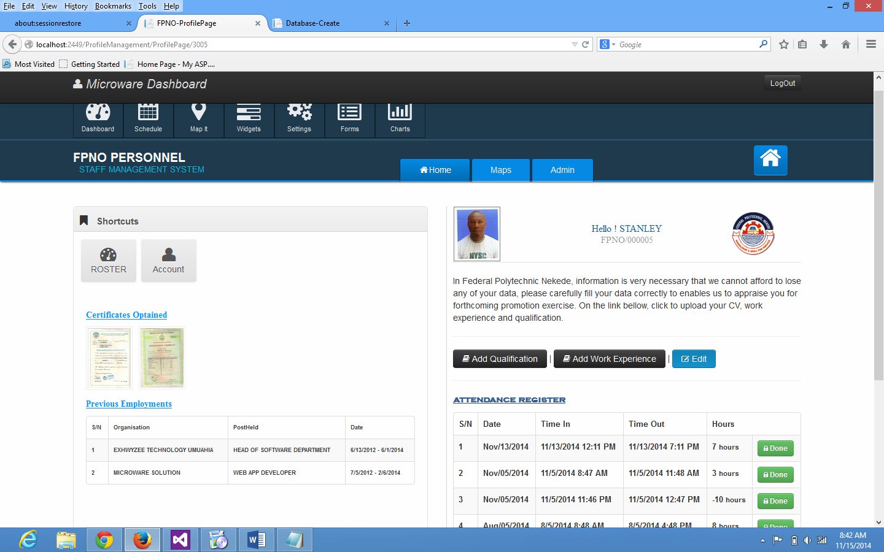
Fig 3.11 Main menu
The main menu will produce or provide an interface between the four staff files after the files have been designed.

3.14.2 OUTPUT SPECIFICATION
The output data from the new system will be inform of a form and short listed names for the answers generated from questions by the computer, the computer processing of the input data. This will include the following: a) Staff records keeping summary: b) Report generation

- Staff Records Keeping Summary
Code | Field name | Field description | Field length | Field Type | Format
01 | J staff | Junior staff | 4 | Numeric | 9(4)
02 | S staff | Senior staff | 4 | Numeric | 9(4)
03 | A staff | Academic staff | 4 | Numeric | 9(4)
04 | Instr | Instructors | 2 | Numeric | 9(2)
05 | Techno | Technologists | 2 | Numeric | 9(2)
06 | Techni | Technicians | 2 | Numeric | 9(2)
07 | Nostaff | Non- academic staff | 3 | Numeric | 9(3)
08 | Total |  | 3 | Numeric | 9(3)

Staff record keeping: format is as follows:
Federal Polytechnic Nekede,
P .M.B Box 1036, Owerri.
Staff record keeping December, 2007

SUMMARY
Academic staff 49
Non-academic staff 188
Total 237
- Rector 1
- Registrar 1
Administrative officer 3
- Bursar 1
Principle Accountant 1
- Director of medical service 1
Principle of medical officer 1
Chief Matron 1
Nursing sister 3
- Chief Librarian 1
Senior librarian 1
Higher librarian officer 1
Library officer 6
- Director of works services 1
Assistant Chief technical officer 1
Assistant chief engineer 1
Technical officer 1 4
Technical officer 11 8
Senior technical officer 12
Technical officer 8
Technician 6
- Head of works superintendent 1
Senior foremen 6
Chief driver
Chief lecturer 10
Principle lecturer 9
Senior lecturer 14
Lecturer 1 10
Lecturer 11 6
Lecturer 111 10
- Chief instructor 2
Assistant chief instructor 2
Principle instructor 1 3
Principle instructor 11 2
Senior instructor 2
Higher instructor 3
- Assistant chef technician 3
Principle technician 4
Senior technician 10
Technician 1 15
Technician 11 10
- Chief executive officer 1
Assistant chief executive 4
Principle executive officer 5
Senior executive officer 6
Junior executive officer 1
Executive officer 10
- Senior sports coach 1
Assistant sports coach 1
Sport coach 2
- Personnel services 2
Chief typist 1
Senior typist 1
Confidential secretary 1 2
Confidential secretary11 1
- Chief security 1
Assistant chief security 1
Security 1
Total 237

B. Report generation (promotion letter).
Federal Polytechnic Nekede
P.M. B ox 1036, Owerri.
Our Ref …………………… your Ref ………………. Date ……………..
Mr/ Mrs/Miss ……………………………………………………………...
NOTIFICATION OF PROMOTION
……………………….
REGISTRAR
Design of Input Files
The input files being considered are:
  - Curriculum vitea (for Employment).
  - Discipline files.
  - Staff attendance list.
  - Promotion file.
  - Personnel file.

INPUT FILES DEFINITION TABLE
    - Curriculum Vitea (for Employment file)
Field name | Field description | Length | Type | Format
Snam | Staff name | 23 | Alphabetic | X(23)
Pad | Permanent address | 30 | Alphanumeric | X (30)
Cad | Current address | 35 | Alphanumeric | X (35)
Pop | Place of birth | 15 | Alphanumeric | X(15)
Dob | Date of birth | 8 | Numeric | 9(8)
Nat | Nationality | 12 | Alphabetic | X (12)
Sori | State of origin | 30 | Alphabetic | X(30)
Sex | Sex | 5 | Alphabetic | X()
Mst | Marital status | 6 | Alphabetic | X(6)
Dep | Department | 23 | Alphabetic | X(23)
Un | Unit | 20 | Alphabetic | X(20)
Qua | Qualification | 40 | Alphanumeric | X(40)
Nch | Number of children | 2 | Numeric | X(2)
Post | Post sort for | 25 | Alphabetic | X(2)
Wexp | Work experience | 8 | Alphanumeric | X(8)
Sag | Salary grade | 2 | Numeric | 9(2)
Pub | Publication | 43 | Alphabetic | X(45)

    - Discipline File
Field name | Field description | Length | Type | Format
Atwpy | Attendance to work per year | 3 | Numeric | 9(3)
Illeg | Illegal involvments | 45 | Alphanumeric | X(45)
Forged | Forged certificate | 45 | Alphanumeric | X(45)
Astw | Absent from work | 3 | Numeric | 9(3)

    - Staff Attendance File
Field name | Field description | Length | Type | Format
Dat | Date | 8 | Alphanumeric | X(8)
Snam | Staff name | 23 | Alphabetic | X(23)
Artm | Arrival time | 8 | Alphanumeric | X(8)
Dtim | Signature | 8 | Alphanumeric | X(8)
 |  | 13 | Alphanumeric | X(13)

    - Personnel File
Field name | Field description | length | Type |  | Format
Snam | Staff name | 23 | Alphabetic |  | X(23)
Padd | Permanent address | 25 | Alphanumeric |  | X (25)
Cadd | Current address | 25 | Alphanumeric |  | X (25)
Pop | Place of birth | 15 | Alphanumeric |  | X(15)
Dob | Date of birth | 8 | Alphanumeric |  | X(8)
Nat | Nationality | 20 | Alphabetic |  | X (20)
Sori | State of origin | 20 | Alphabetic |  | X(20)
Sex | Sex | 5 | Alphabetic |  | X()
Mst | Marital status | 6 | Alphabetic |  | X(6)
Dep | Department | 23 | Alphabetic |  | X(23)
Un | Unit | 20 | Alphabetic |  | X(20)
Qua | Qualification | 20 | Alphanumeric |  | X(20)
Pheld | Post held | 25 | Alphabetic |  | X(25)
Dfap | Date of first appointment | 8 | Alphanumeric |  | X(8)
Dlap | Date of last appointment | 8 | Alphanumeric |  | X(8)
Sgrad | Salary grade | 2 | Numeric |  | X(2)
Nod | No of duplication | 2 | Numeric |  | X(2)
Ben | Benefits | 30 |  | Alphabetic | X(30)

    - Annual Performance Appraisal (For Promotion File)
Field name | Field description | length | Type | Format
Sname | Staff name | 23 | Alphabetic | X(23)
Dept | Department | 25 | Alphabetic | X(25)
Sch | School | 30 | Alphabetic | X(30)
Dop | Date of birth | 8 | Alphanumeric | X(8)
Ein | Education | 50 | Alphabetic | X(50)
Oact | Other academic title | 48 | Alphabetic | X(48)
Dofa | Date of first appointment | 8 | Alphanumeric | X(8)
Prom | Promotion since appointment | 43 | Alphanumeric | X(43)
Post | Present post grade | 23 | Alphanumeric | X(23)
Ade | Additional
 | Qualification
Pub | Publication | 45 | Alphabetic | X(45)
Adr | Administrative responsibilities | 25 | Alphabetic | X (25)
Coth | Course taught in 3 years | 60 | Alphanumeric | X (60)
Sig | Signature | 8 | Alphanumeric | X(8)

- Processing: When data are entered through the keyboard or any other input machine, the computer accept and stores the data for further processing. Computer then checks for errors, and if there is any found or detected, it sends error message to the user for necessary corrections. If there are no errors, execution continues an in the end the desired output is achieved.
- Storage medium: The information should be stored in a magnetic tape or magnetic disc, with this, the operator has easy access to the file.
- Mode of processing: In this system, the mode of processing files is random file accessing mode. In this mode, each storage location on the storage medium has an address that is used on order to access the record stored in tat location. This is recommended because unlike in sequential files necessary where records are referenced one at a time according to the key of storage. Each memory location is random file accessing could easily be referenced without accessing records that come before the record of interest.
3.14.3 Validation process.
The inputs to the system are validated at different levels. These are: a) Before input to the system: b) During data preparation: c) On input to the system: d) Within the operation program itself.
3.14.4 Design of input specification
Here, the researcher will consider the input from the data to the computer. The type of data to be feed into the system in this regard the following input are needed in the self personal data file which include staff name, date of birth, sex, place of birth, local government of staff, state of origin, nationality, hubbies and curriculum activities.
- The staff recruitment data file will require input such as institution attended and qualifications (certificate) courses attended and requirement for the present appointments.
- The staff personal data update file issued to update the personal file and as such will almost the same input as that of the staff personal file.
- The general staff enrolment, this file will require the staff name, position held in the institution, grad level, date of promotion and current working or office status.

3.14.5 File/ Database Specification
Output design
The output data from new system will be inform of a form and short listed names for the answer generated from questions by the computer, the computer will then process the data’s of the input design.
  - Overview Of The Proposed Systems Flowchart
The data to be worked with are collected and keyed into the system through the keyboard unit. The data are staff names, addresses, departments etc. After this exercise, the data are validated at different levels. The CPU carries out the processing and operations involved; Employment file, Discipline file, Promotion file, personal file and Master file are created respectively.
These file will be serving as reference files in the system. Using the records in these files, the processes of updating and printing of records can be performed depending on users demand. After this, the master file is finally updated to reflect the current records and to have a backup copy as well.
After this, the computer operator goes on to process the overall result of the operation, which leads to the production of the desired output. These outputs are finally printed out as hard copy.

CHAPTER FOUR
SYSTEM IMPLEMENTATION
4.1 INTRODUCTION
The work pattern of any establishment will be affected whenever a new system is introduced. The activities involves under the implementation phase which includes: a) Creating master files: b) Acquainting all necessary equipment: c) Coding and debugging of all computer programmers: d) Preparing documentation for data preparation. When all the above mentioned activities have been performed, the conversion phase can then begin with data collection.
The three types of people that are involved in this phase include:
- The user department, which is directly affected.
- The people that have to do with change-over.
- The top management who will be directly affected.

4.2 Justification of the Programming Language
A program is a set of computer instructions written in any computer language of the execution of one operation or another. Various programming languages exist today. The coding of the procedure flowchart into an appropriate level language but in the causes of this research work, using SGL Server (Structured Query Language) as ASP.Net Server language has been found ideal to be used. It is used because: i) It is flexible: ii) It is Object oriented programming language: iii) The language is machine independent.

4.3 System Control
Once a system is created, record controls are triggered to regulate it access and distribution. A human resource employee may separate documents from a personnel file and keep them n a local cabinet with a control log to control and track access. Role security may be set on a repository allowing access to approved users. Software may be identifying the official record, versions, copies and distribution. Just as the record of organization come in as variety of formats, the storage of records can vary throughout the organization, file maintenance may be carried out by the owner, designee, records repository, clerk, records may.
4.4 System Requirement
This is where to specify the requirement needed for this project in order to produce it necessary task.
4.4.1 Software requirement
In this new system, due to the size of the program and also the database which is to last for very long period of time, it is advisable to use an operating system that has the needed features to be required in the system, to that effect, the researcher recommend the use of window7 and all other enhanced or improved version of windows that are more enhanced.
Examples;
- Operating System: Microsoft Windows Vista, Window XP and above.
- Server System: Microsoft Internet Information Service. (IIS) Version 7.0 and above.
- Frame Work: Microsoft dot Net Frame work 4.5 recommended.
- IDE: Microsoft Visual Studio 2012 Ultimate.
- Database: Microsoft SQL Server 2008 or 2012.
Also, antivirus like MacAfee, is needed to avoid virus affection into the new systems.
4.4.2 Hardware Requirement
The hardware requirement in this system involves an advance technology of computer. The hardware requirement includes.
- Processor Type: Intel Pentium M and above.
- Speed: 1.3GHZ and above
- Memory: 2.0GB of RAM and above.
- Hard Disk Drive: 40GB hard disk and above.
- Display: Intel Graphic Display Unit with 15inches display monitor/ flat screen.
- I.O Device: USB Flash Drive for back-up, External Hard disk drive and Network adapter, and CD-Rom
4.4.3 People
The people involved here are the system analysts who take control or charge of the system. Here we referred them as the staffs of the institution that are taking care of the system, know when it is faulty or ok. It is also known as the people who implement and give instructions to the computer.
4.5 Implementation Details
4.5.1 Coding
Coding is the process of writing, assembling and compiling computer codes. Codes are simply the instructions for hardware and software. It is also the process of securing, data safe of the work done in a computer system. ASP.Net Html, C++, Visual basic are a kind of computer programming language that you can use to create your own web page in a system. Here coding makes it possible to create staff record keeping, computer software, applications and web site. Your browser, Operating system, the applications on your phone, Facebook, and this web sites, they are all made with codes.
4.5.2 System Testing
Testing of this new system involves the use of sample called "test data" that ascertain the effective functioning of the programming and actual implementation is the expected test. Running is expected to last for a minimum of 12 calendar months to test efficiency and inefficiency and make correction where necessary.

4.5.3 Training and Re-training of staff
Training of staff is necessary and could be enhancing through lectures, use of handbooks course (either full time or part time courses). It is also the amount of training required for various categories of personnel will depend upon the complexity of the system and the skills presently available. The system analyst would be required to ensure that all persons involved with the new system are able of making it an operational success. The following would be used as appropriate:
- Handbooks: This will be produced to enable staff to have knowledge of the system.
- Publication of the articles in staff management.
- Organizing a forum where questions can be asked by the staff and answered by implementation team.
- Organizing a visit o the computer center.
- Sending a number of staff on computer courses.
4.5.4 FILE CONVERSION
This involves converting the manual file of the old system into computer files. It is suggested by the researcher that the entire manual file be converted into computer readerable form. It is equal suggested by the researcher that magnetic disk should be acquired by the institution as the medium of storing files. During conversion process, manual files data and information should be carefully verified and validated on the screen before storing into the magnetic disks (Hard Disk).

4.5.5 Changeover procedure
The changeover stage involves the way by which the new system will be employed to replace the old system or current system. The type of change over procedure that I suggested for the institution is the parallel change over.
There are three ways of change over procedure:
- Parallel change over: Here the old and new system is running side by side for a while and compared, one advantages of this is that if eventually the new system fails, the institution can revert the old system. Although, this procedure is not cost effective, but if found to be reliable and effective, and then whole organization can back the old system and continue with the automated system.
- Direct change over: This is obtaining when the new system is introduced without any reference of the old system i.e. the old system is faced out and abandoned completely.
Advantages
- The advantage of this is that it is cost effective since it is only the staffs in the new system are paid.
- It also reduces the cost of paper and other stationeries.
- It does not waste storage spaces since conversion is based from old to new adopted system.
Disadvantages
- When the system fails, the overall project is ruined.
- It does not allow any room for comparison between the old and the new system.

- Pilot change over: This method could be used in conjunction with either direct or parallel method. In using this method, the new system is introduced bit by bit. This makes personnel transfer easier. This bit by bit introduction is applied in the direct or parallel methods where certain tasks required the attention of the analyst. These include: a) Co-ordination of the changeover: b) Communication during the changeover: c) Controlling the errors which may appear at the stage: d)Monitoring the system and getting a feedback since the system is dynamic and capable of changing with the above mentioned. The pilot changeover is recommended, because it allows the management to take decisions step- by – step.
4.5.6 COMMISSIONING
It involves handing over the complete system o the user. This will probably involves the first line support of the systems developed completing forms such as inventory sheet that shows the hardware and software component commissioned along with details of configuration setting and a check list of the test carried out.
4.5.7 USERS MANUALS
At the start bar, select programmers from the start menu, this action will now cause the programme menu to be displayed. Then on the programme menu, select the programming language, this action will automatically load the ASP.Net using C-sharp environment, you then now open your file where you have worked, saved and start your records.

4.5.8 MAINTENANCE DETAILS
System maintenance in the process of supporting the system after it has been improved. The maintenance stages of the newly implemented system will include the effort taken to make sure that the system is continuously meeting the need of the institution. Since the equipment and the system are in use, personnel need to be monitored and maintain, so that the system will not break down and even if it eventually dose, the fault will be identified and corrected immediately.

CHAPTER FIVE
SUMMARY, RECOMMENDATION & CONCLUSIONS
5.1 SUMMARY
Generally, staff record keeping has a vital role it plays in every sphere of life every field of study, marketing and institutions and since it has such important to the society, computer scientist around the world are fighting together to discover the factors that could enhance the learning and the problems encountered during staff record keeping and it’s management with the use of manual and mechanical methods.
5.2 RECOMMENDATION
With the growing of Federal Polytechnic Nekede Owerri, and based on the finding f this study, it is recommended that the processing of staff book keeping and staff records at any level should be computerized. This is to enhance quick and accurate information which will be used for deciding making process .It is also recommended that the implementation of the new system should be done using the pilot method in combination with the parallel method of the changeover. Staff training and educating should be carried out as soon as possible.
The staff should be made members of the implementation team to help gain good will from other staffs. When the implementation process is over, adequate security control measure in form of management control should be provided to ensure that the system achieves the study stated benefits.
5.3 CONCLUSION
Computer, due to its inexhaustible use in the society, the staff involves in automation of systems have effectively attracted great deal of attention in recent times. Computer is welcomed because it has brought excitement, great productivity, less work, less waste and new application in almost every field. Organization is usually proper when their manager act on the bases of relevant information. To generate relevant information efficiently, you need quick access to the data from which the required information is produced. Data management, which focuses on data collection, storage and retrieval, these constitute a cost activity for any organization. Typically, efficient data management requires the use of a computer database. Actively, it involve in keeping staff records are enormous but the very- very essential for the proper management of staff strength. Hence, the need for staff record keeping of Federal Polytechnic NekedeOwerri is to ensure accuracy, adaptable speedy operation of data and greater storage capacity.

AREAS OF FURTHER STUDIES.
To project work has its focus on only the working staff of the institution. In that case there is also need to study about the retirement staff records and student records which is also part of the data base management information system. Also, study should be made in order to find a way of inter connecting the institution in a local area network (LAN) from easy assert to be made to document by authorized personnel.
Finally, file which was briefly stated in this study, thus this file is also part of data base management system.
REFERENCES
Asika, Ogu E.O (1996): “Computer Application in Employment System” A focus on personnel department. Nichen Group of companies (Nig) Ltd, Logos.
David, Amdmatin B. (1990): “Inventory Control Theory and Practice” Indian Publishers, Indian.
Donald, H.S (1981): “Compute in Business and Int. Reduction” Daily Time New Paper, London.
Dock, V.T. & E.C Essick (1981): “Principle of Business, Data processing with Management Information System” Rosary Publishers, London.
Heith, C.O. (1971): “Programming with Fortran” Megatek publishers, London.
Igwe S.O. (2001): “Introduction to Information Processng and Basic Programming” Nig. Matix Educational.
Ike C.N. and Onwere S.A (2003):“Electronic Processing concepts and Applications” Aba.
Enke .D. (1992): “Management Information System” USA McGraw Hill.
Senberg, J.M (1981): “Dictionary of Computer, Information Processing and Telecommunication” John Willey and Son’s Ltd, London.
Owland, F. (1969): “Basic Programming Language” Warlow publishing company, London.

APPENDIX I- SAMPLE OUTPUT
Login Page
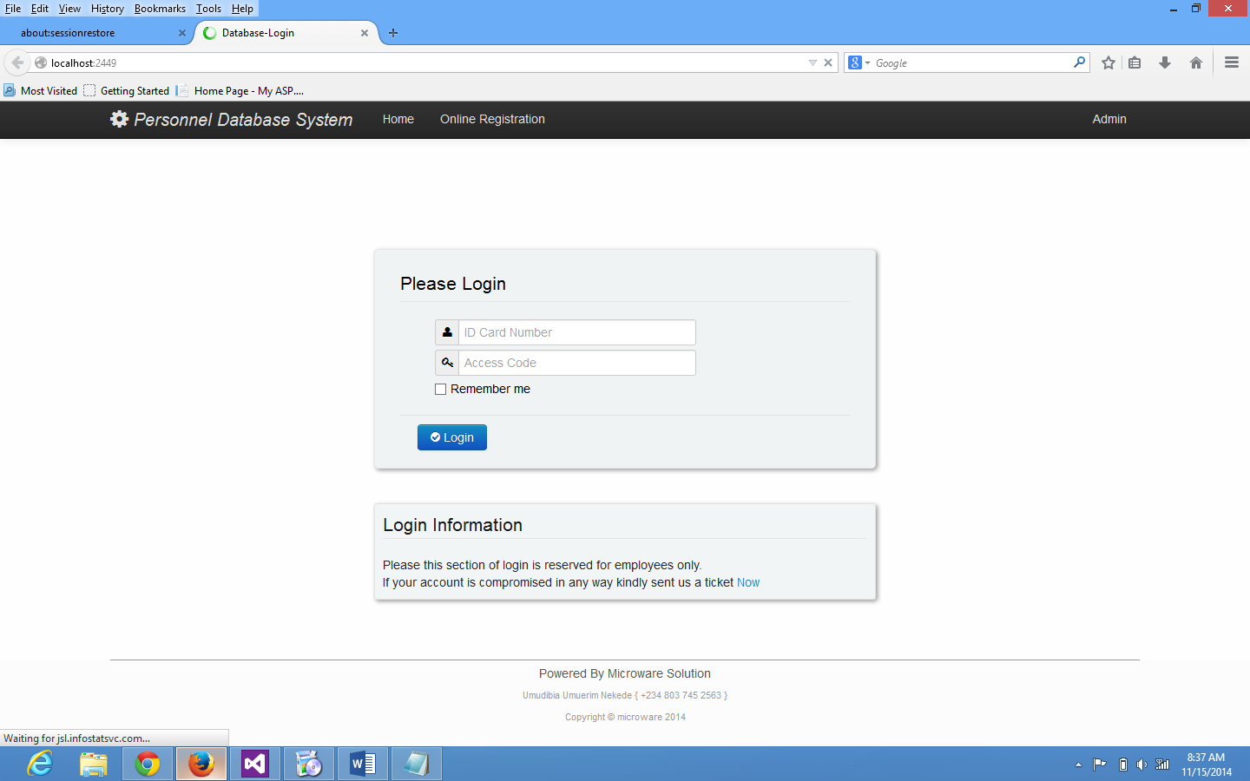

Online Registration Page
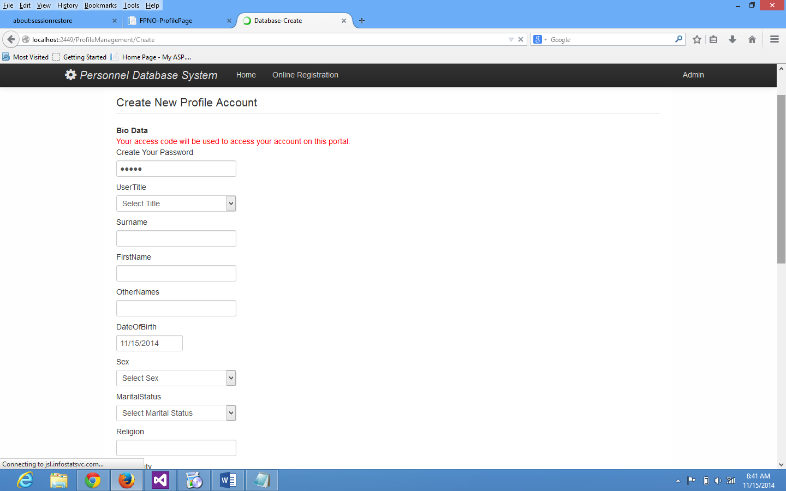
Profile Page

Add Qualification Page
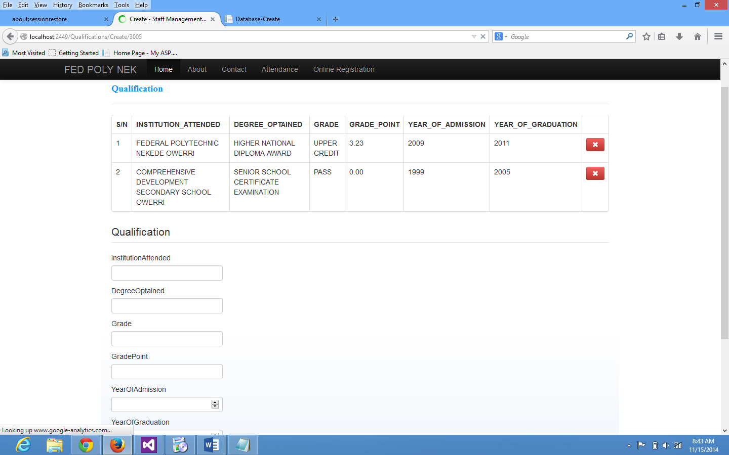

Working expirence
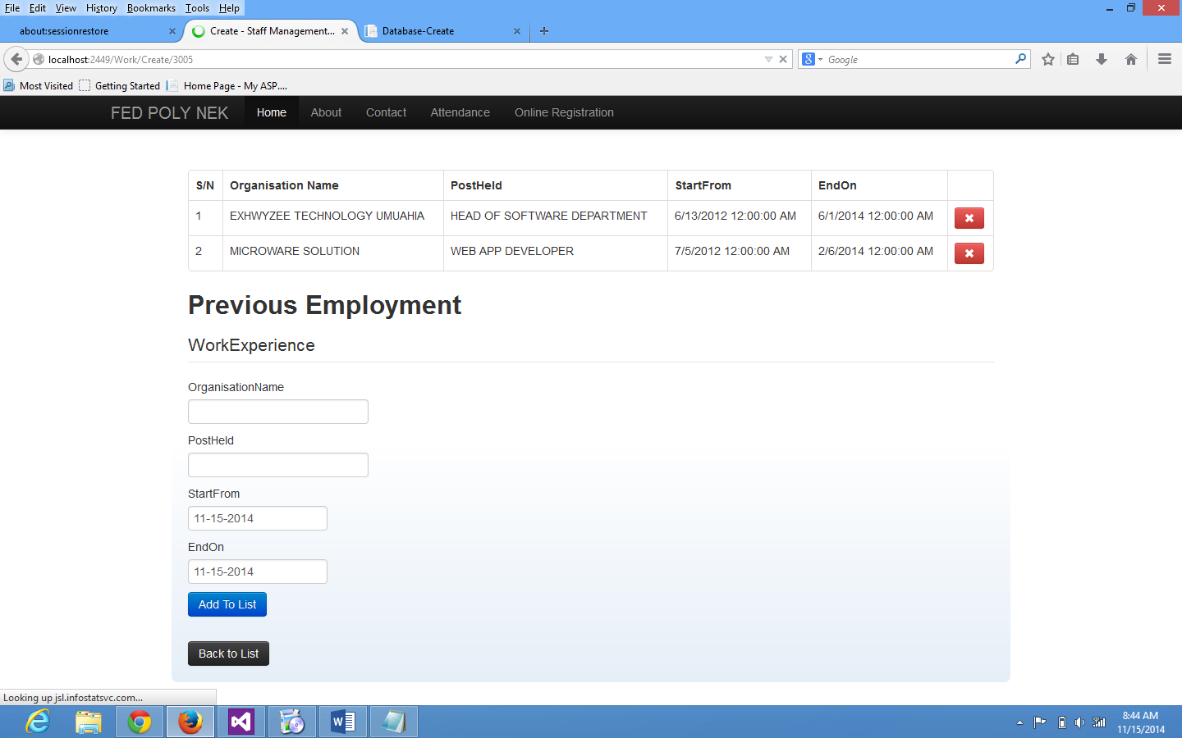

Attendance Register
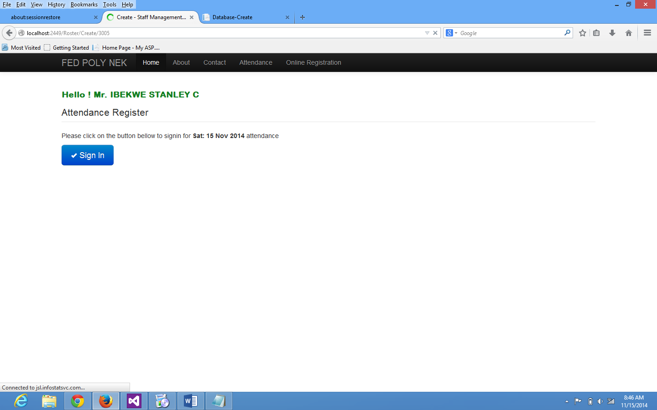

Appendix II -SOURCE CODES
SOURCE CODE
using System;
usingSystem.Collections.Generic;
usingSystem.Data;
usingSystem.Data.Entity;
usingSystem.Linq;
usingSystem.Web;
usingSystem.Web.Mvc;
usingPreciouseProject.Models;

namespacePreciouseProject.Controllers
{
public class WorkController : Controller
{
privateDataContextdb = new DataContext();

//
// GET: /Work/

publicActionResult Index()
{
varworkexperiences = db.WorkExperiences.Include(w =>w.PersonalData);
return View(workexperiences.ToList());
}

//
// GET: /Work/Details/5

publicActionResult Details(int id = 0)
{
WorkExperienceworkexperience = db.WorkExperiences.Find(id);
if (workexperience == null)
{
returnHttpNotFound();
}
return View(workexperience);
}

publicActionResult _UserExperience(int id = 0)
{
var work = db.WorkExperiences.Where(x =>x.PersonalDataId == id);
ViewBag.Work = work.ToArray();
returnPartialView();
}

publicActionResult Create(int id=0)
{
ViewBag.id = id;
return View();
}

//
// POST: /Work/Create

[HttpPost]
publicActionResult Create(WorkExperienceworkexperience, int id=0)
{
ViewBag.id = id;
if (ModelState.IsValid)
{
workexperience.OrganisationName = workexperience.OrganisationName.ToUpper();
workexperience.PostHeld = workexperience.PostHeld.ToUpper();
workexperience.PersonalDataId = id;
db.WorkExperiences.Add(workexperience);
db.SaveChanges();
returnRedirectToAction("Create", new { id = id });
}

return View(workexperience);
}

